Composing with Pattern Blocks
Ways to form the blue rhombus  Two green triangles:  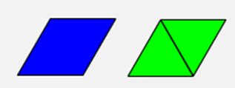 | Ways to form the red trapezoid  Three green triangles:  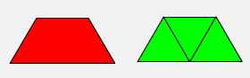  One blue rhombus and one green triangle:  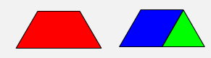
Ways to form the yellow hexagon  Two red trapezoids:  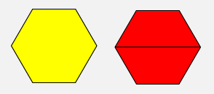  Six green triangles:  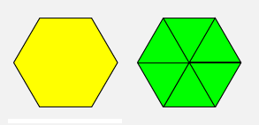  Three blue rhombuses:  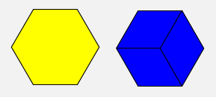 | Two blue rhombuses and two green triangles:  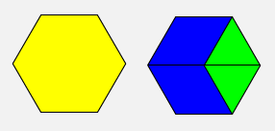  Three green triangles and one red trapezoid:  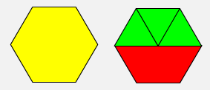  Three different shapes:  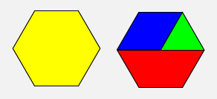  (Other combinations are also possible.)

